Dear Sir/Madame:
I have tried using Visual Micro’s GDB debugger with Visual Studio 2017. The Visual Micro debugger always hangs up during the debugger initialization phase:
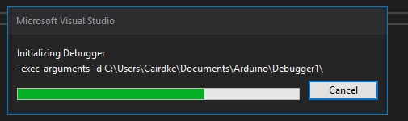
It does not always hang up at the same place during initialization but it always hangs up during initialization.
After a few minutes I get the following error message:
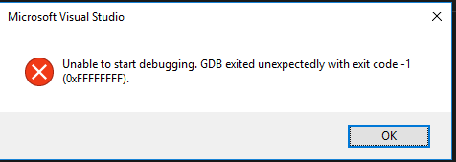
I have gone to the task list and microgdb.exe is always running, until I get the above error message and microgdb.exe disappears from task list.
I have the latest versions of all software installed:
Visual Micro GDB 15.170821.1
Visual Micro IDE 1709.3.1
Visual Studio 15.3.3
Arduino IDE 1.8.4
Any advice would be appreciated!
Ken Caird

